Christopher Gonzalez
Professor Jennifer Holst
CSCI 401
22 April 2025
pwn.college Lab 4
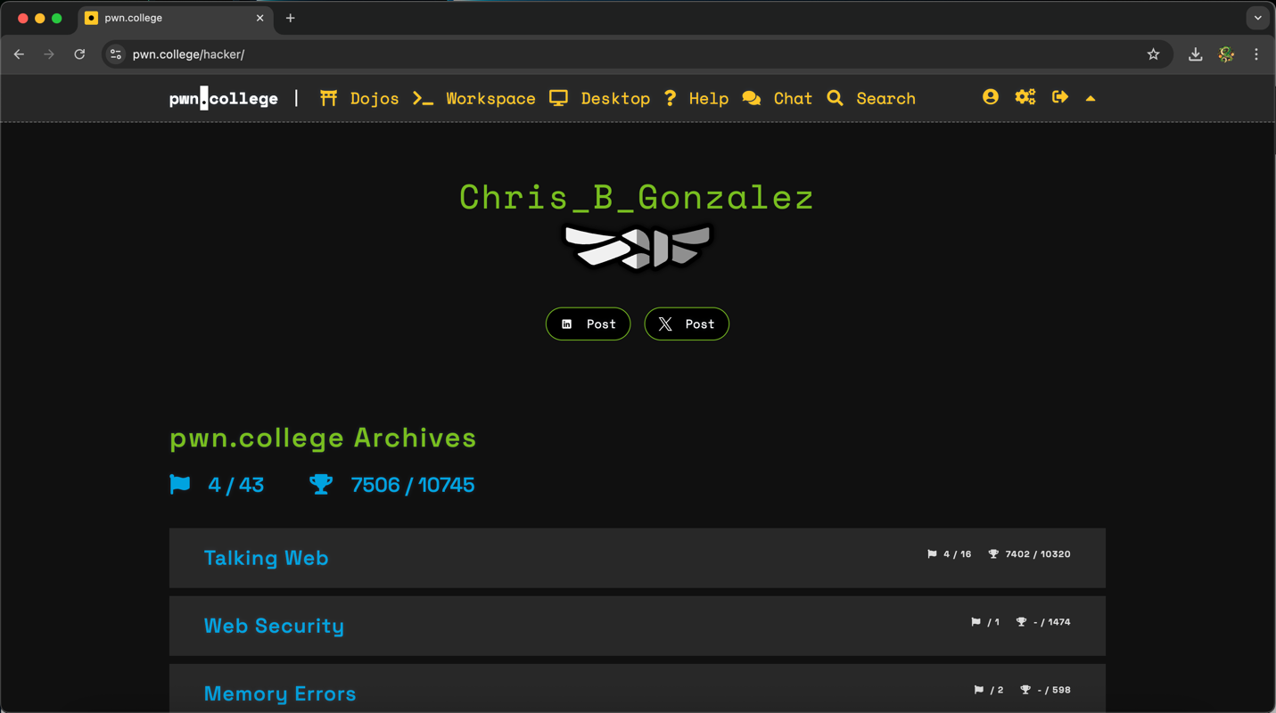

Challenge 1: Decoding Practice
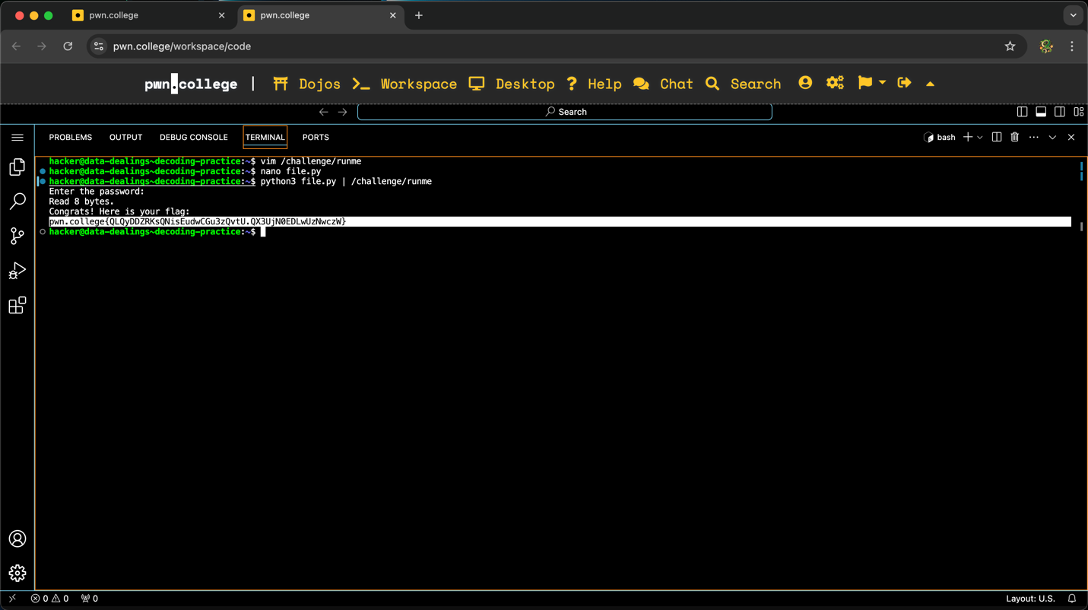
To obtain this flag, I started the challenge and opened the VSCode Workspace. Like the challenges completed in Lab 3, this set of flags would also require me to enter the password but under new circumstances. I started by doing vim /challenge/runme to extract the password and understand the specifics of the challenge. Upon inspection, I discovered I had to provide the password (1011111111100010101110101011101111001010101011111111001111110000) as a byte array. The series of 1’s and 0’s represent bits, and a byte is 8 bits total. To convert this binary into bytes, I created a program called file.py that would do the conversion for me (Note: all programs used for this lab will be entered in file.py). The code used can be seen below:
import sys
# Convert binary string to bytes
binary_string = "1011111111100010101110101011101111001010101011111111001111110000"
byte_array = bytearray(int(binary_string[i:i+8], 2) for i in range(0, len(binary_string), 8))

# Write the byte array directly to stdout
sys.stdout.buffer.write(byte_array)
Afterwards, I executed the program and had the output sent to /challenge/runme by entering python3 file.py | /challenge/runme. Afterwards, the program checked the password and gave me the flag.

Challenge 2: Encoding Practice
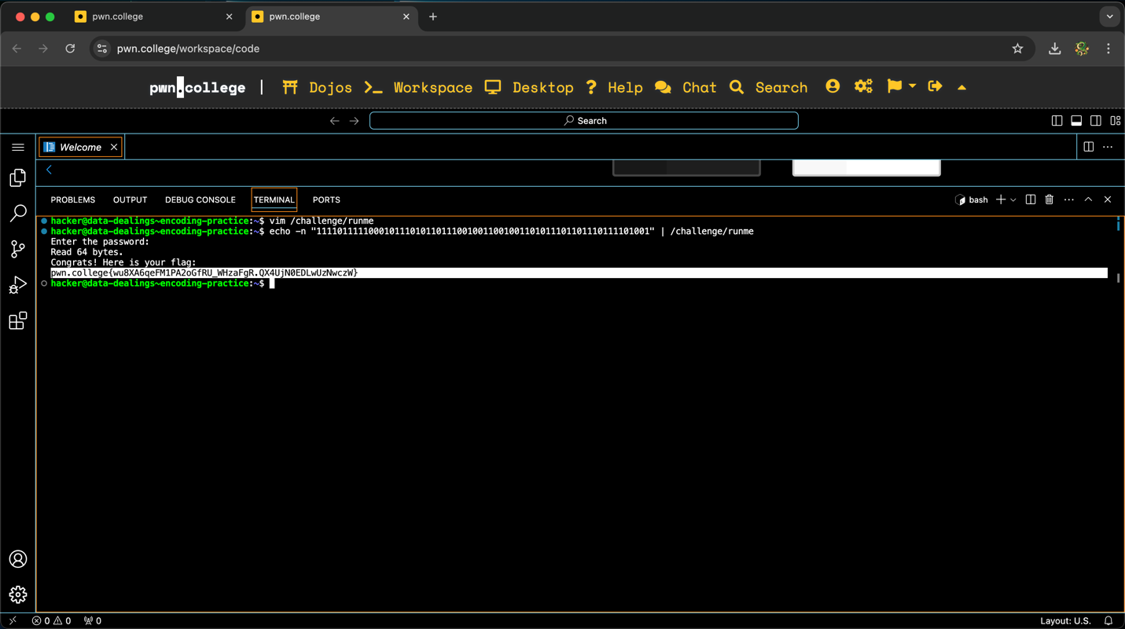
To obtain this flag, I started the challenge and opened the VSCode Workspace. This challenge was similar to the previous one, but was arguably much easier because rather than converting binary into bytes, I had to convert the bytes to binary. Upon vimming the program, I discovered the password to be (in hex notation) \xf7\xc5\xd6\xe4\xc9\xae\xdd\xe9. If we ignore the \x for each byte, we get f7 c5 d6 e4 c9 ae dd e9. Although I could have written a program that converts the hex values to binary, I decided to decode manually as personal practice. The binary version of the password is 1111011111000101110101101110010011001001101011101101110111101001, and I entered this by using the echo -n command (in case newlines were counted). Afterwards, I got the flag.

Challenge 3: Hex-encoding ASCII
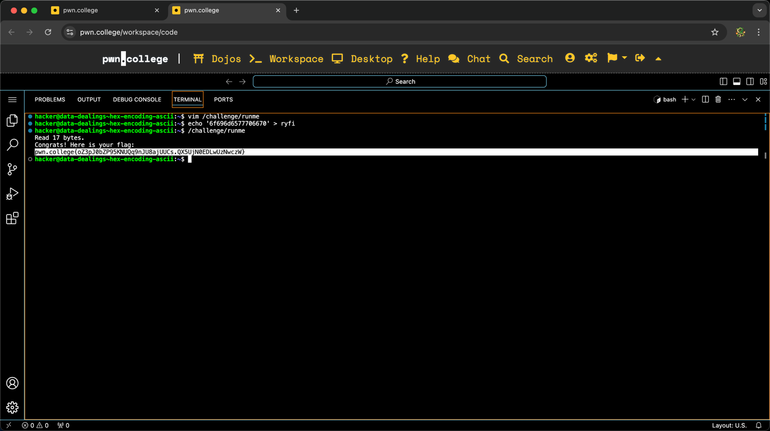
To obtain this flag, I started the challenge and opened the VSCode Workspace. This challenge required me to convert a string of text into bytes in latin1. I started by vimming the /challenge/rumne program to extract the password (oimewpfp) and then converting this into bytes from latin1 (or l1 for short). The result was 6f 69 6d 65 77 70 66 70. Vimming the program also revealed that the input is expected to be entered by using a ryfi file rather than directly entering it when prompted. I stored the encoded password into an ryfi file by doing echo ‘6f696d6577706670’ > ryfi and then ran the challenge, resulting in the flag.

Challenge 4: Nested Encoding
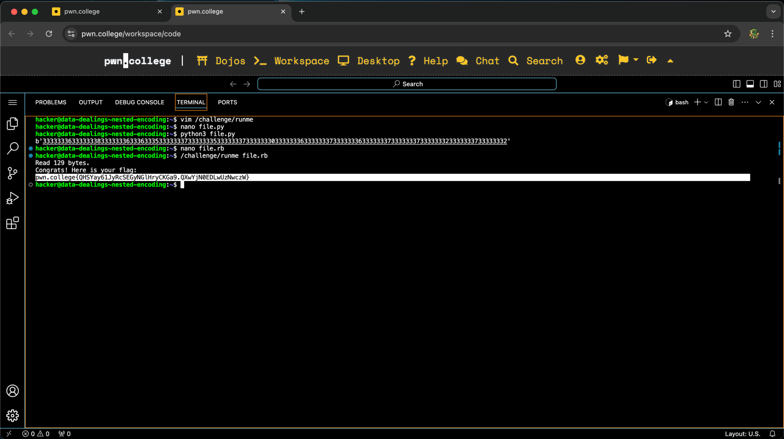
To obtain this flag, I started the challenge and opened the VSCode Workspace. After vimming the program, I determined the correct password to be hnupggrr, but the program expects to receive the password after it has been encoded from l1 four times. I accomplished this by creating a program that encodes the password four times like so:
password = 'hnupggrr'
encoded_password = password.encode('l1')

encoded_password = encoded_password.hex().encode('l1')
encoded_password = encoded_password.hex().encode('l1')
encoded_password = encoded_password.hex().encode('l1')
encoded_password = encoded_password.hex().encode('l1')

print(encoded_password)

After saving this file, I executed it, which printed the encoded password seen in the image. As it can be seen, the encoded password is a really large number which I had to store in an rb file. Finally, I executed the /challenge/runme program with the rb file I created with the encoded password, which game me the flag.

Challenge 5: Hex-encoding UTF-8
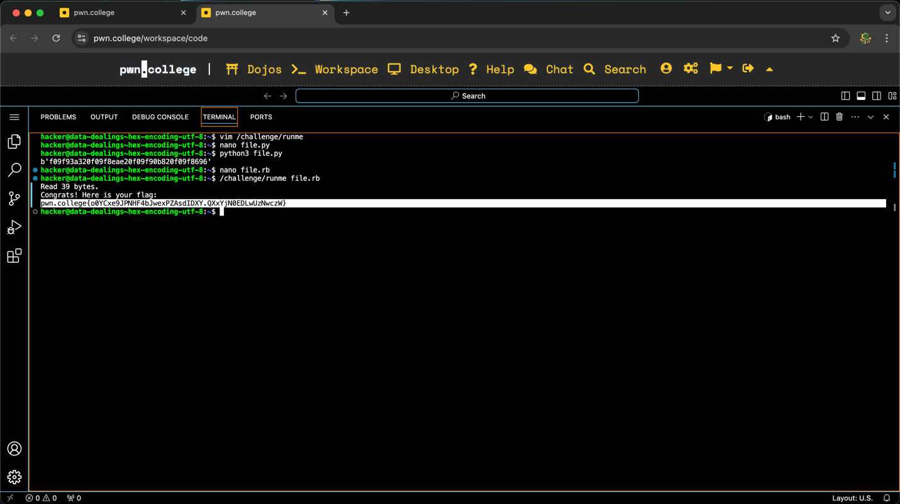
To obtain this flag, I started the challenge and opened the VSCode Workspace. This challenge was special in the sense the password was a series of four emojis rather than numeric values
(📣 🎮 🐸 🆖). Rather than entering this, I was expected to convert the emojis from UTF-8, which is a global standardized character set containing essentially all possible characters (including emojis). The program used to convert the password can be seen below:
password = '📣 🎮 🐸 🆖'
encoded_password = password.encode('utf-8')

encoded_password = encoded_password.hex().encode('utf-8')

print(encoded_password)
After saving and executing the program (file.py), the result was f09f93a320f09f8eae20f09f90b820f09f8696. This password was saved in file.rb (as /challenge/runme expects the input to come from a rb file) and then used to get the flag.
Challenge 6: UTF Mixups
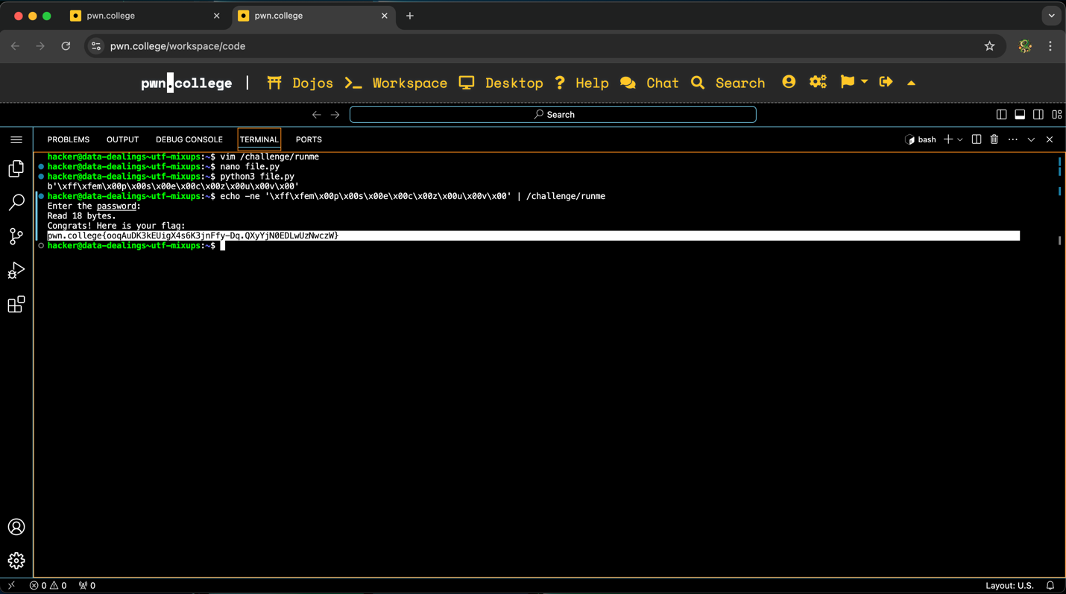
To obtain this flag, I started the challenge and opened the VSCode Workspace. The instructions for this challenge introduced me to a different Unicode encoding, known as UTF-16. Unfortunately, this can often lead to confusion and security vulnerabilities for systems that use other versions (like UTF-8 seen in the last challenge). After vimming /challenge/runme, I noticed the correct password was mpseczuv, but I had to decode this from latin1 (l1) and then encode it from utf-16. This is because the program will do the inverse for the entered password. To accomplish this, I created the following program:
correct_password = b"mpseczuv"
# Decode from latin1
decoded_string = correct_password.decode('latin1')
# Encode using utf-16
utf16_encoded = decoded_string.encode('utf-16')
print(utf16_encoded)
Once this program was made, I executed it by entering python3 file.py in the terminal. This printed out the transformed version of the password, which was \xff\xfem\x00p\x00s\x00e\x00c\x00z\x00u\x00v\x00. With this information, I entered the password by doing echo -ne '\xff\xfem\x00p\x00s\x00e\x00c\x00z\x00u\x00v\x00' | /challenge/runme. The -e option allows for the inclusion of \x without it being interpreted by the program. Afterwards, I got the flag.

Challenge 7: Modifying Encoding Data
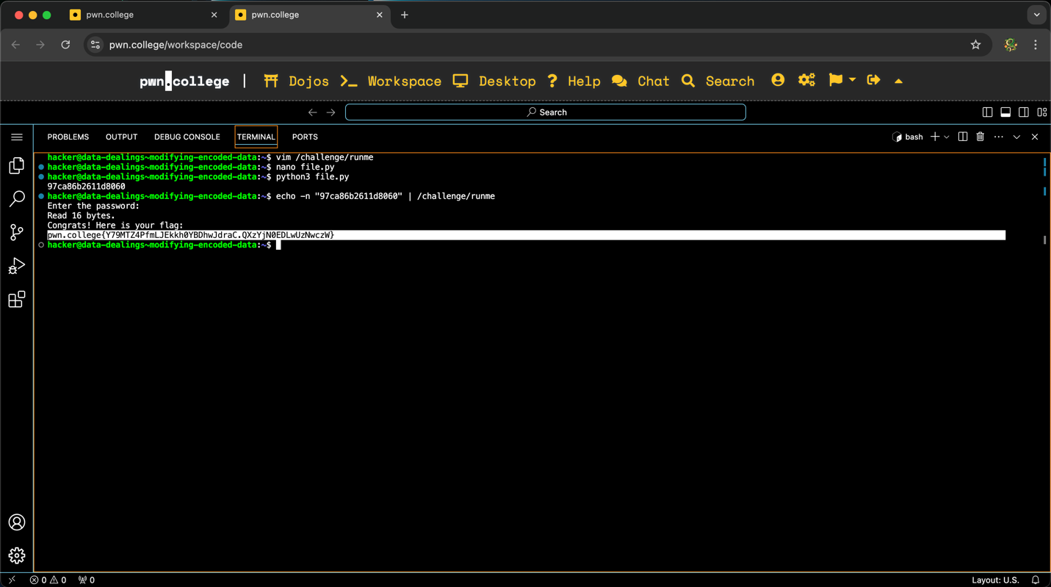
To obtain this flag, I started the challenge and opened the VSCode Workspace. The first step I took was to vim the /challenge/runme program to collect the password and analyze how the entered password would be transformed for this challenge. The correct password, as seen from the program, was \x06\x08\xd1\x16+h\xacy, but entering this would not result in the flag. This is because the /challenge/runme program will take the entered password, reverse the order of the bytes, and decode if from l1. Therefore, the password I enter must be the inverse of the transformations mentioned. I created a program that would take the correct password, convert it into hex, reverse the order of the data, and print the result. The code can be seen below:

correct_password = b"\x06\x08\xd1\x16+h\xacy"
hex_password = correct_password.hex()
reversed_hex_password = hex_password[::-1]
print(reversed_hex_password)
Afterwards, I executed the program, which printed 97ca86b2611d8060. Using this information, I entered it as the password by doing echo -n “97ca86b2611d8060” | /challenge/runme, resulting in the flag.

Challenge 8: Decoding Base64
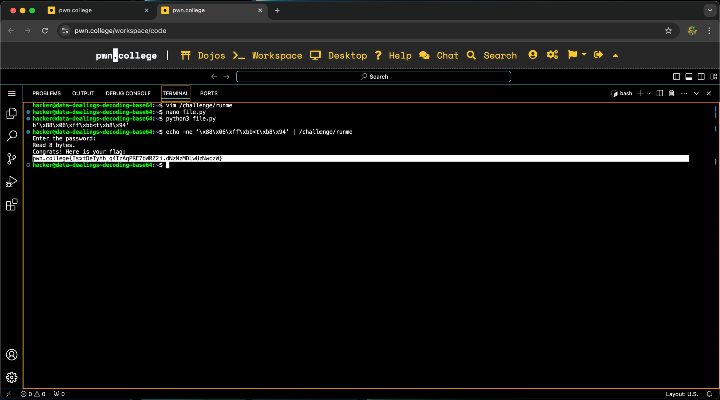
To obtain this flag, I started the challenge and opened the VSCode Workspace. This challenge introduced me to Base64, which a binary-to-text encoding/decoding that represents binary data in an ASCII string format from a set of 64 characters. As the name suggests, my goal was to decrypt the password that was in Base64 and enter it as the password. From vimming the /challenge/runme program, I determined the encoded password was “iAb/uzx0uJQ=”. With this information, I created the following program to decrypt the password:
import base64
correct_password = b"iAb/uzx0uJQ="
decoded_password = base64.b64decode(correct_password)
print(decoded_password)
After executing the program, the decrypted version of the password was printed (\x88\x06\xff\xbb<t\xb8\x94). I entered this to the /challenge/runme program by once again doing echo -ne '\x88\x06\xff\xbb<t\xb8\x94' | /challenge/runme, which resulted in the flag.
Challenge 9: Encoding Base64
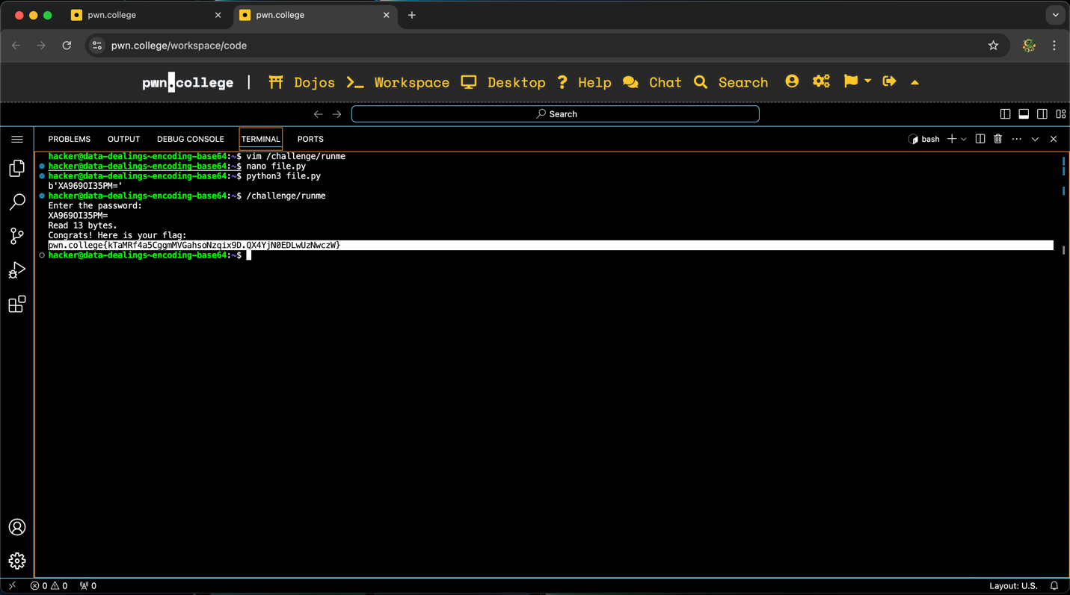
To obtain this flag, I started the challenge and opened the VSCode Workspace. Like the previous challenge, I had to work with Base64, but this time I had to encode the password in Base64 and provide it as the password. By vimming the /challenge/runme program, I determined the original password was “\\\x0fz\xf4\xe27\xe4\xf3”. I modified the program from the previous challenge to perform encryption rather than decryption, resulting in the following:
import base64
correct_password = b"\\\x0fz\xf4\xe27\xe4\xf3"
encoded_password = base64.b64encode(correct_password)
print(encoded_password)
After executing this program, the result was b’XA969OI35PM=’ (but the letter b and the single quotations marks are not part of the password). Since this password was easy to enter, I started the /challenge/runme program and entered the encoded password, resulting in the flag.

Challenge 10: Dealing with Obfuscation
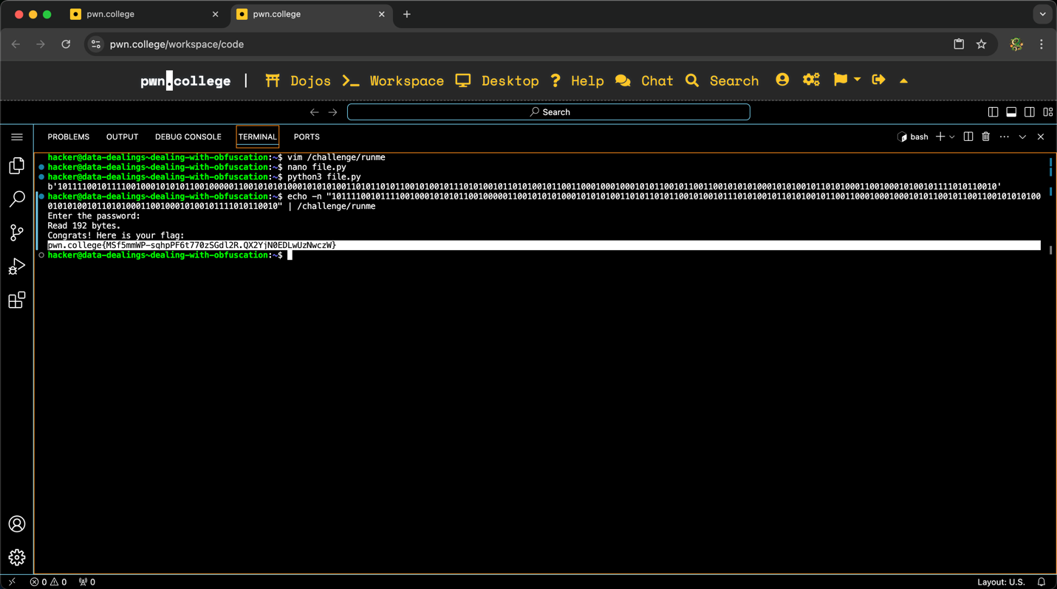
To obtain this flag, I started the challenge and opened the VSCode Workspace. Like all the previous challenges, I began by vimming /challenge/runme to collect the password (b"4^W\x01\xbe\xbd\xa5A"). In addition to this, the program code revealed the correct password went through 5 transformations, which means entering the extracted password would be incorrect. The password was turned to hex, then encoded from l1, encoded from base64, encoded to bits, and finally reversed. This means the password I enter must be in binary. To determine the binary, I created the following program which performed all transformations to the password:
import sys
import base64

def encode_to_bits(s):
return b"".join(format(c, "08b").encode("latin1") for c in s)

correct_password = b"4^W\x01\xbe\xbd\xa5A"

correct_password = correct_password.hex().encode("l1")
correct_password = base64.b64encode(correct_password)
correct_password = encode_to_bits(correct_password)
correct_password = correct_password[::-1]

print(correct_password)
I saved the password and executed it by entering python3 file.py in the terminal. The binary can be seen in the image. With this information, I entered it as the password using the echo -n command, which got me the flag.

Challenge 11: Dealing with Obfuscation 2
Despite my best efforts, I was unable to obtain this flag. This challenge is a more advanced version of the previous “Dealing with Obfuscation” challenge. Upon vimming /challenge/runme for this challenge, I observed the correct password was b"\x08\x9e\xb3zP\x03\x02\x03". However, the password went through 4 transformations. First, the correct password was encoded using base64, then encoded from latin 1, converted to binary bits, and finally had it’s byte order reversed. Initially, I created a program that would print the result of the correct password after going through all transformations, which was b'001001101100110000100110001011001110110001101100100011000010110000101100001011001000110000101100110001100110110010101100011011001000011011101100011011001100110010000110001011001100110000101100'. The problem was that the entered password would also go through a series of transformations. According to the information in /challenge/runme, the entered password would have its byte order reversed, then decoded from latin 1 three times. I attempted to use the binary I discovered and reverse engineer the transformations that would be done on the entered password, but I was unsuccessful in creating a program that would perform the inverse of the transformations, which would’ve been the password I had to enter for this challenge.

